EXPERIMENTNO18

DeterminationandplottingofAntennaHalfpowerbeamwidth. Aim:
TodetermineandplotHalfPowerBeamwidth(HPBW)andto determinetheangularwidthat-3dBpoints

Softwarerequired:
- SCILABversion6.0.1

Program:
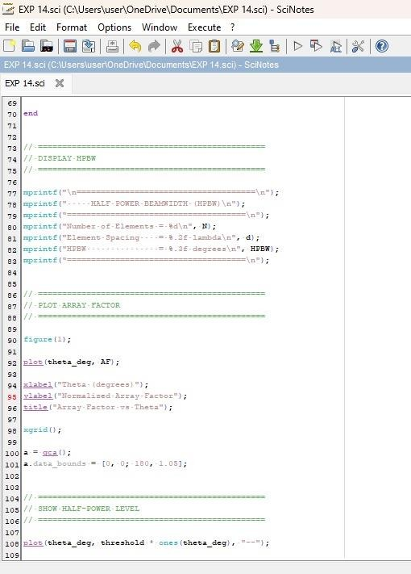

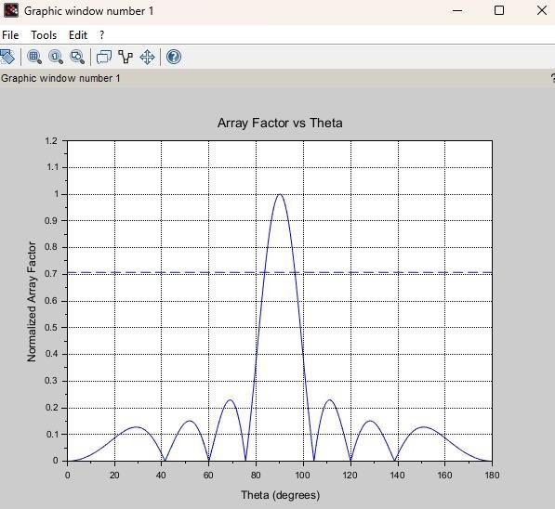
Output:

RESULT:TheexperimentwasdoneandtheHalfpowerbeamwidthof thegivenantennawascalculated.Differentcasestudiesweredone.

